16/02/2026
R1 is the IR emitter LED current limiting resistor
From the datasheet I see the forward voltage I will use is 1.2 and the current is 0.02 amps
Current limiting resistor calculation
3.3-1.2/0.02 = 105 ohms#
I used a 120 Ohm resistor to experiment on the breadboard as shown below
Breadboard set up of testing the 120 Ohm resistor
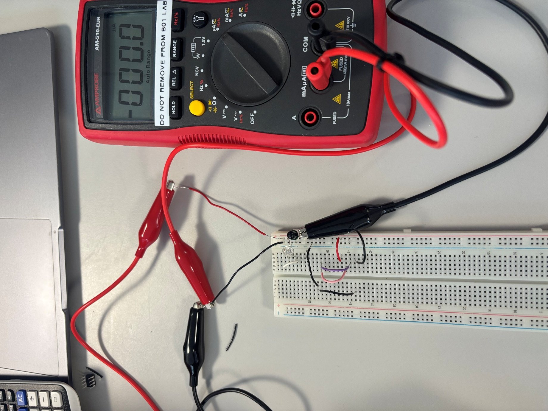
I used this set up to test he current through the photodiode when there is a black surface and a white surface
Testing a black surface
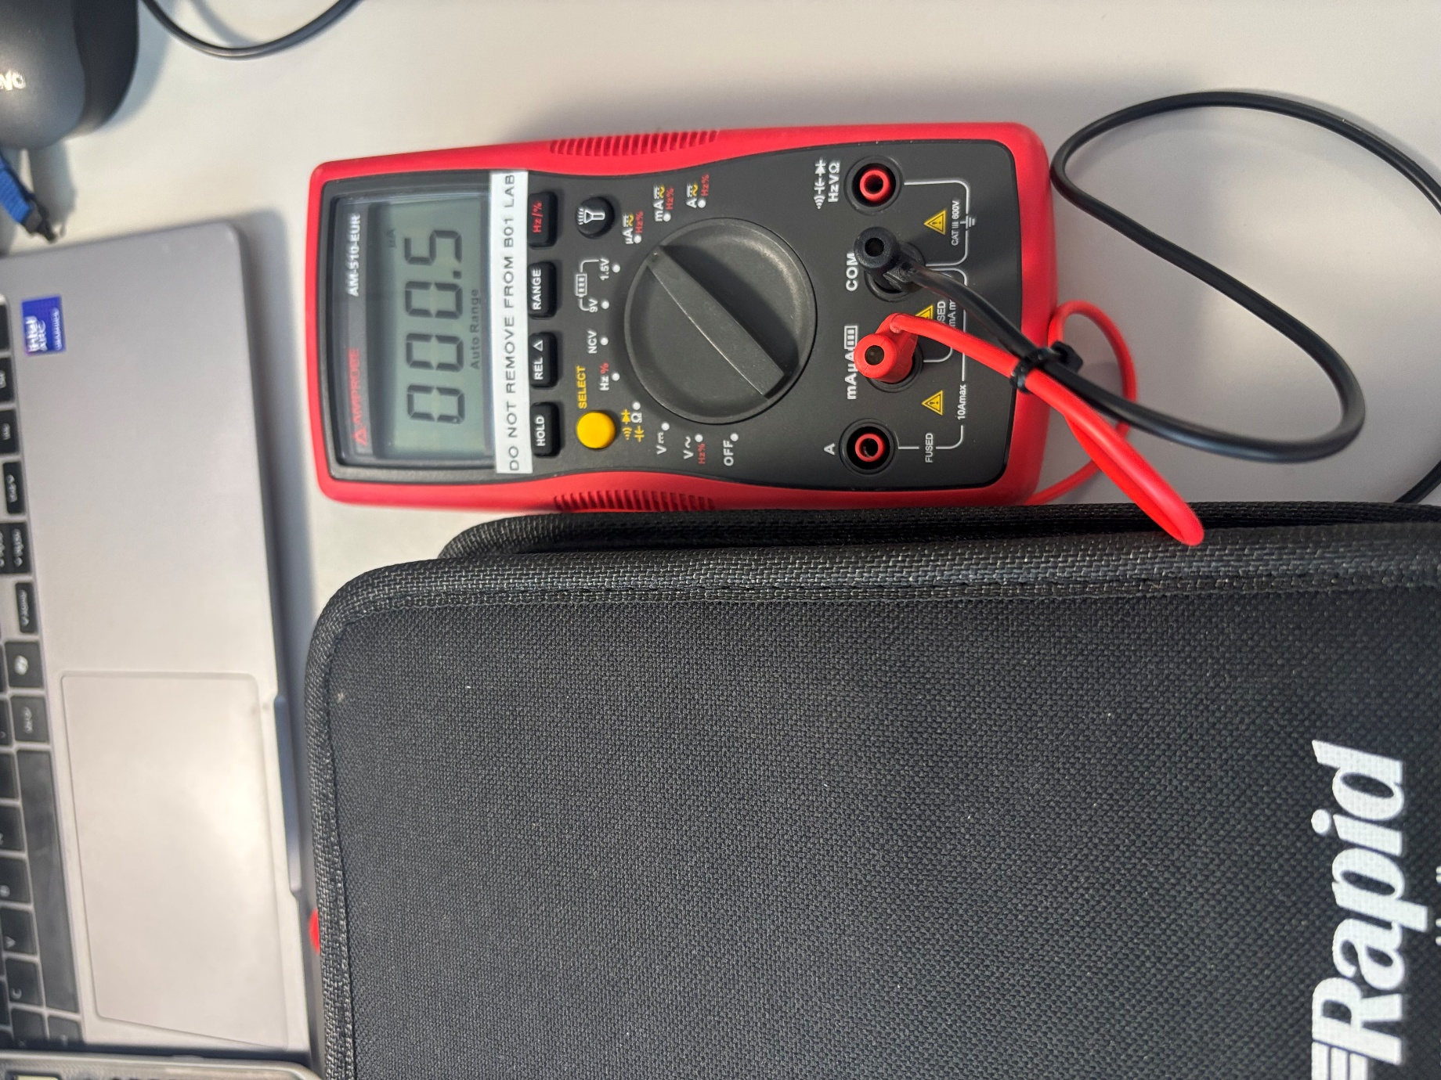

Testing a white surface
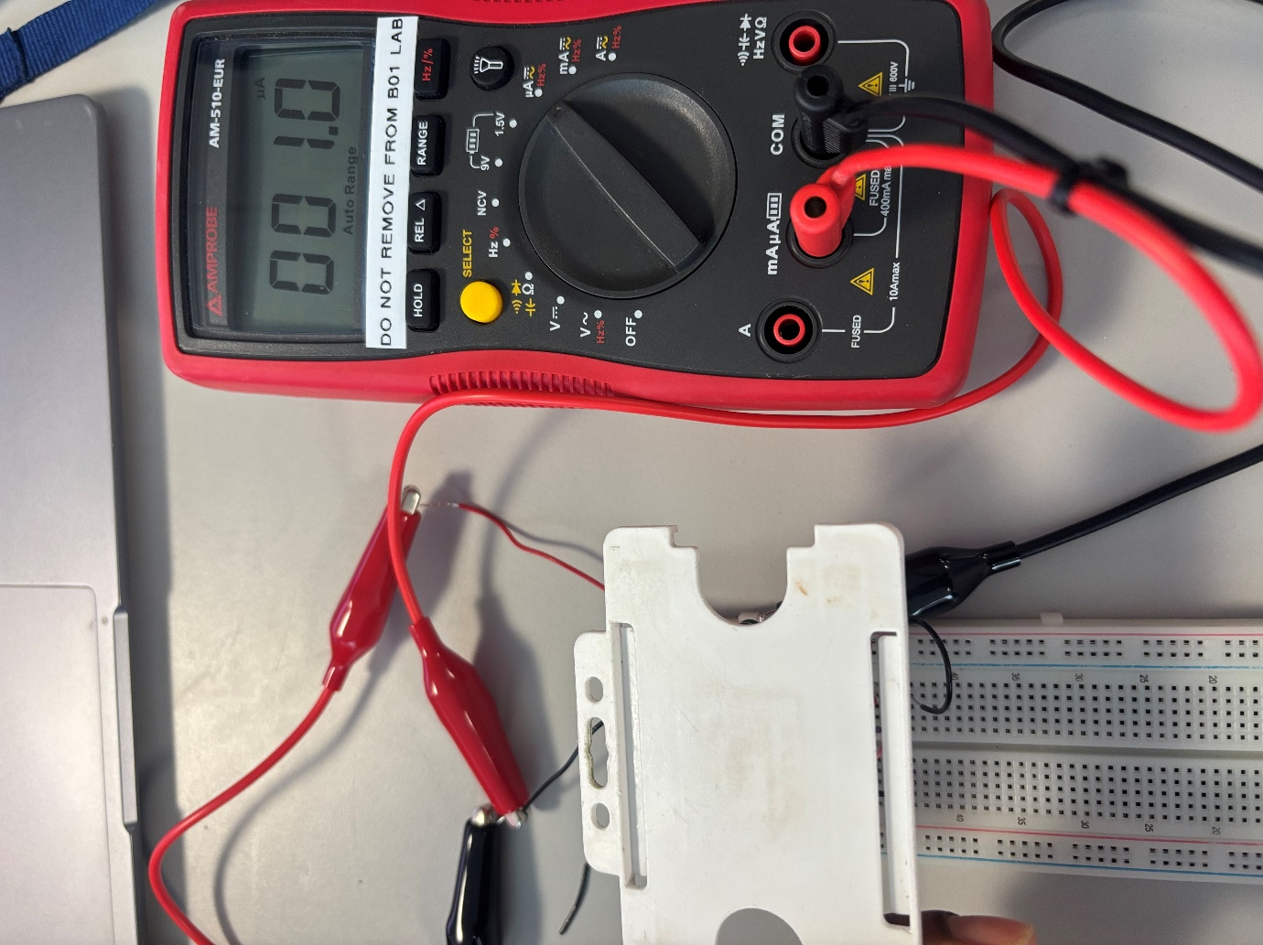
Now I know the 120 ohm resistor is working and I can now use the oscilloscope to test different resistor values for R2
After trial and error with the oscilloscope 2Mohms produced the right output shown below
White Surface: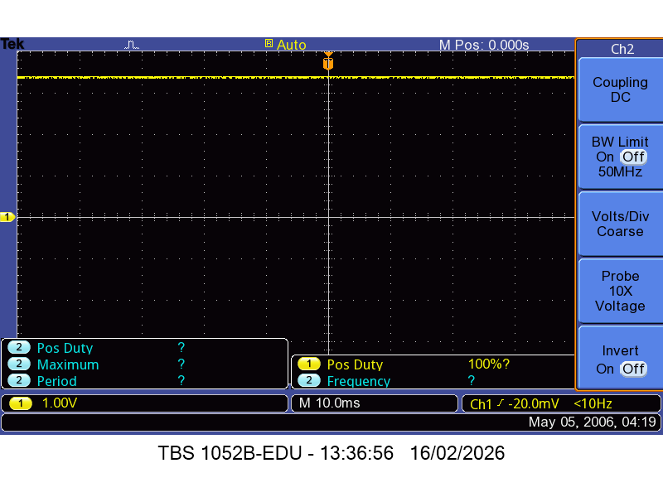
Black Surface:
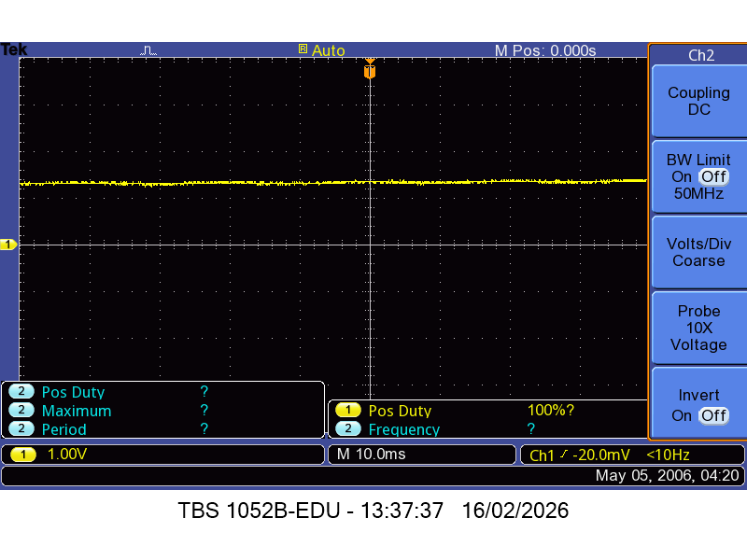
There is a significant difference between a white surface and a black surface which is necessary to differentiate between them when coding the line following algorithm
17/02/2026
I will now translate this to a stripboard layout:
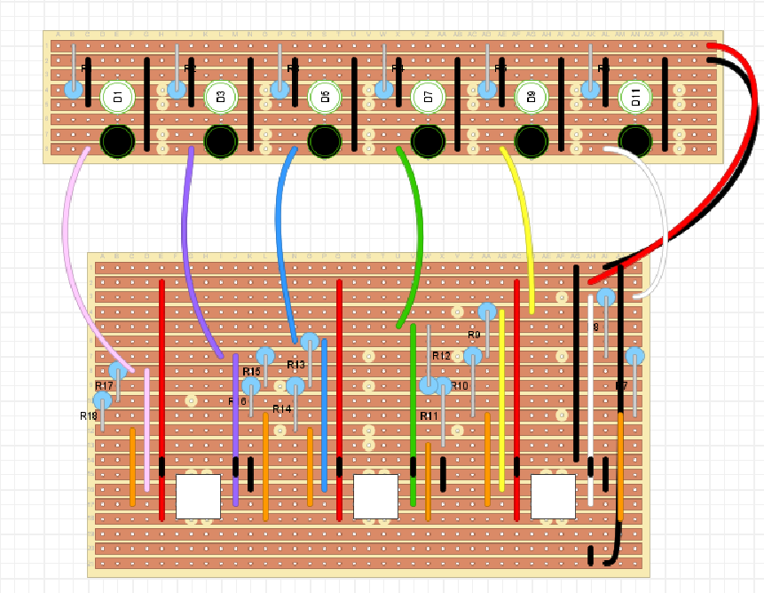

Soldered Board:
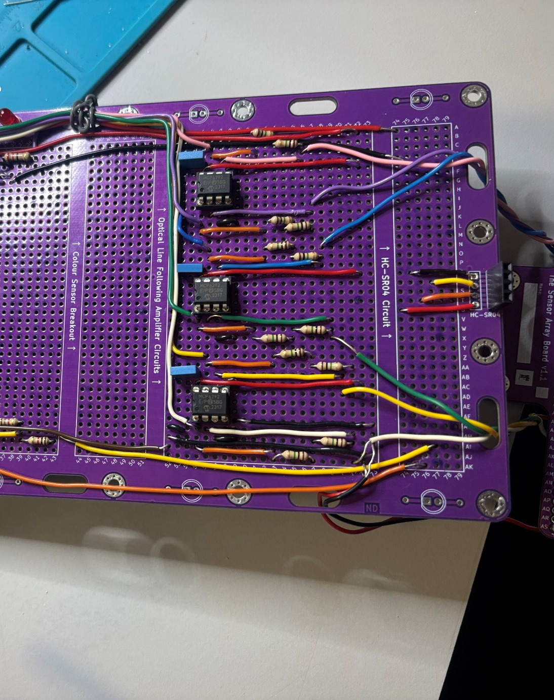
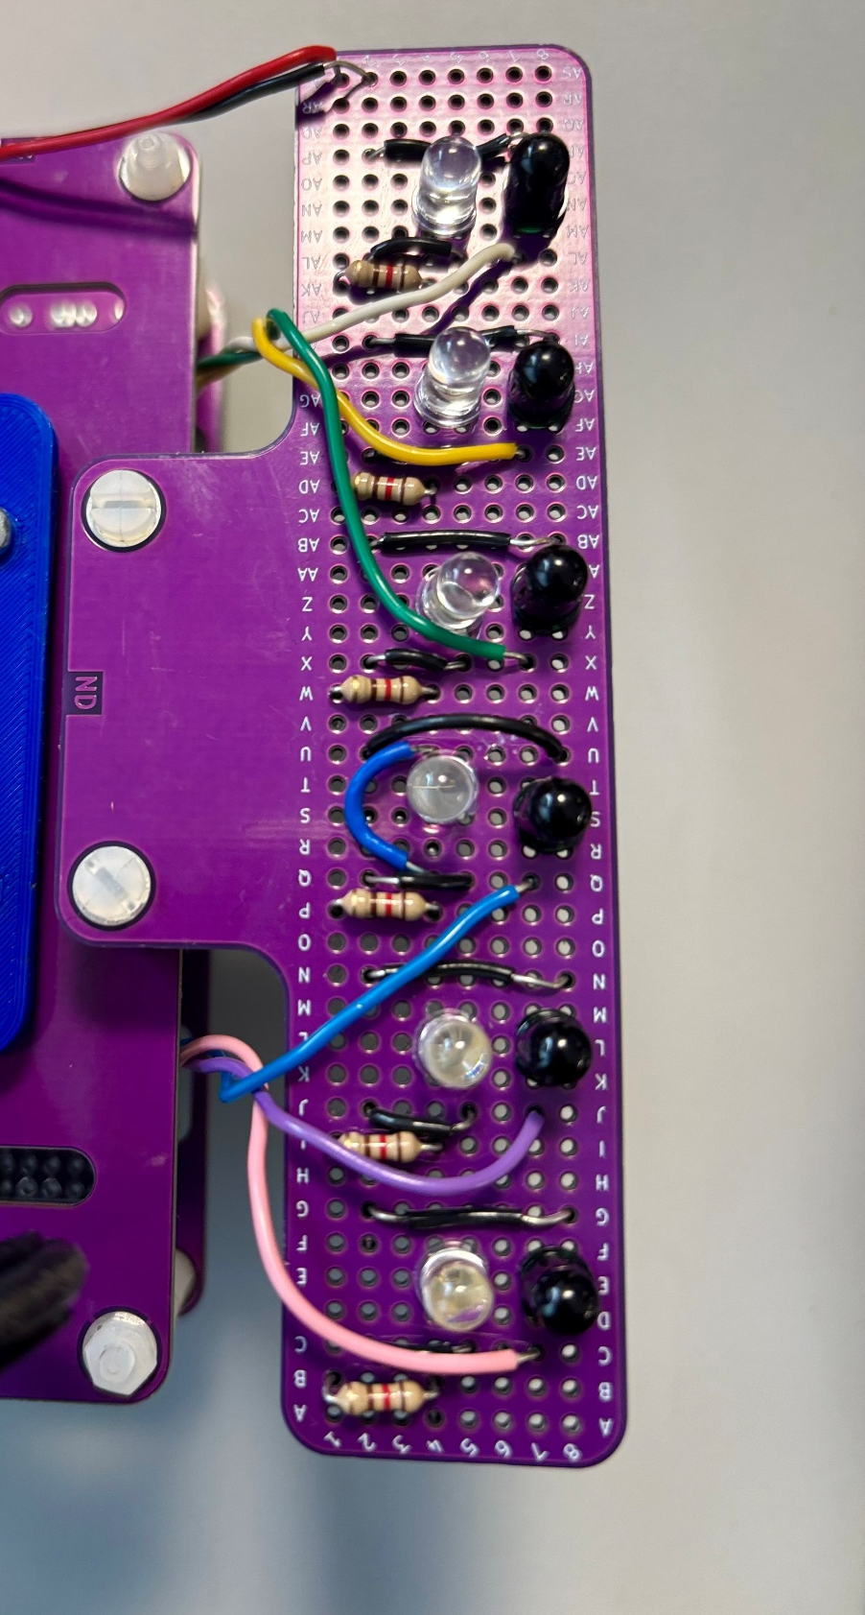
18/02/2026
After fully soldering my circuit, I came across a few problems when I ran this test code
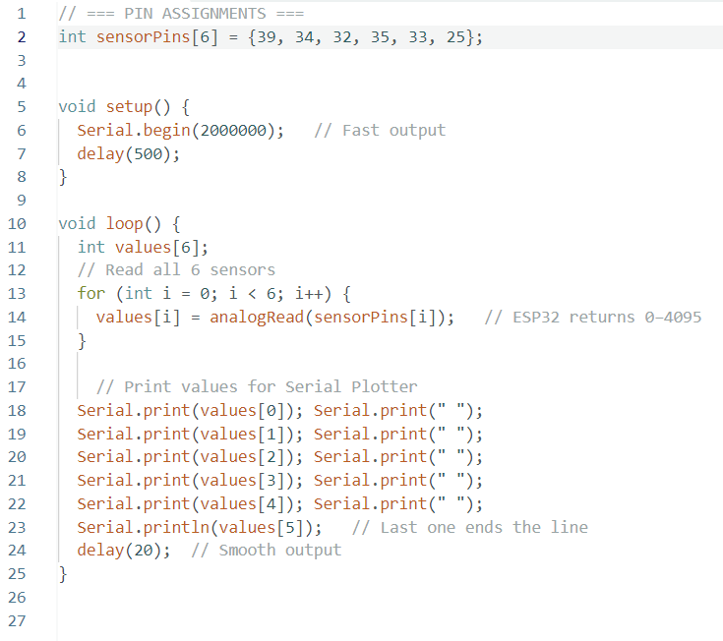
All my sensors didn’t work because I didn’t properly connect it to ground or to voltage. 3 of the sensors still weren’t working I made sure to test continuity on all the cut tracks and I used the oscilloscope to test if the sensors were detecting anything in case my resistors were the problem/ When I decided on using 1M ohm resistors I only tested that on 1 photodiode so if the oscilloscope looked remotely correct then I knew that would be the problem however when I did the output just looked crazy to me. I used a phone to test the IR LED and one of them wasn’t working after replacing this. The sensors worked.
Here is my flowchart for the line following code:

3.3-0.5
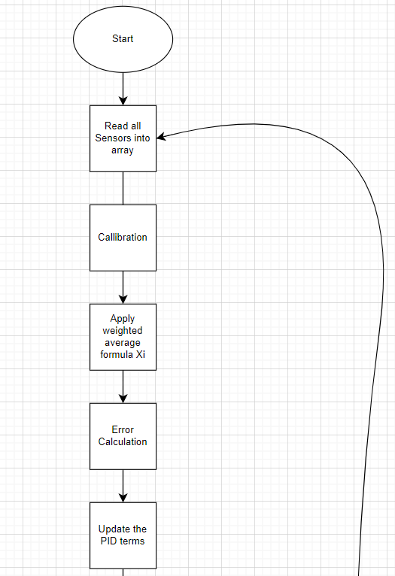
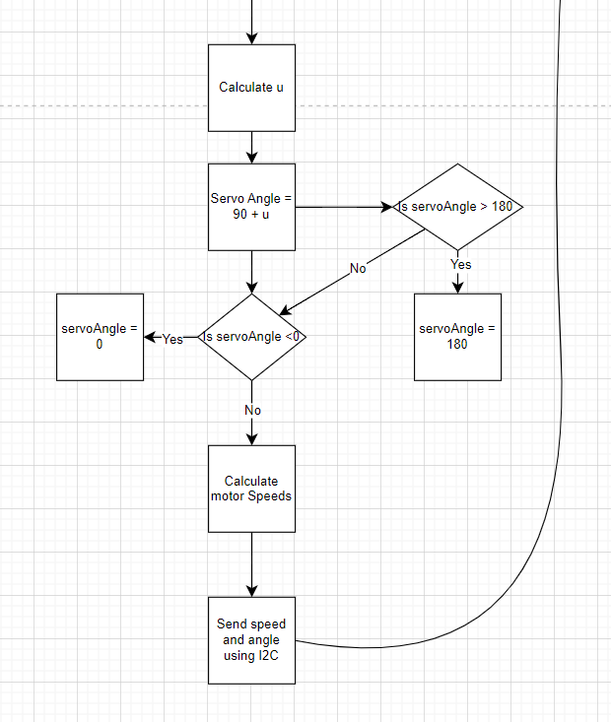

19/02/2026
Code:
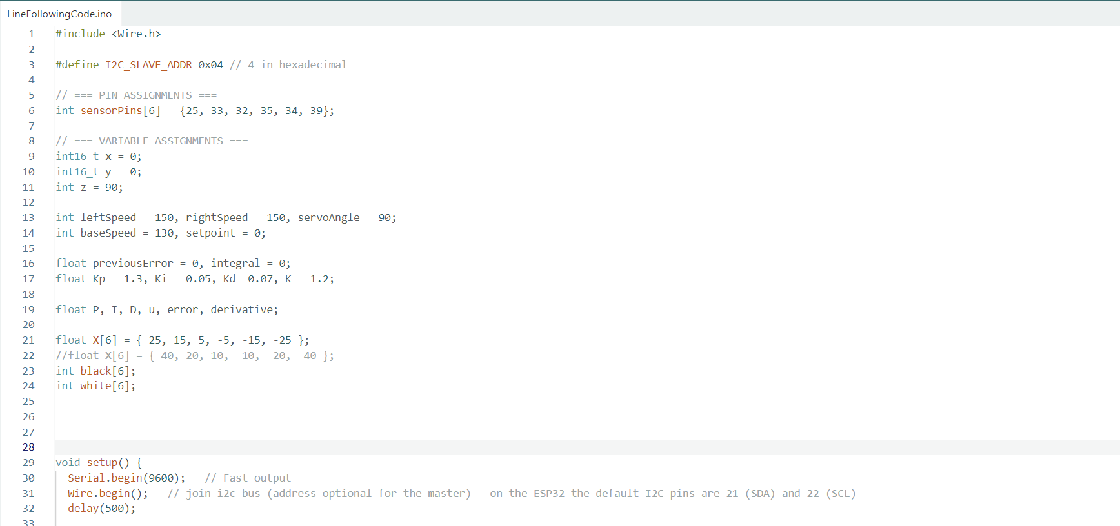
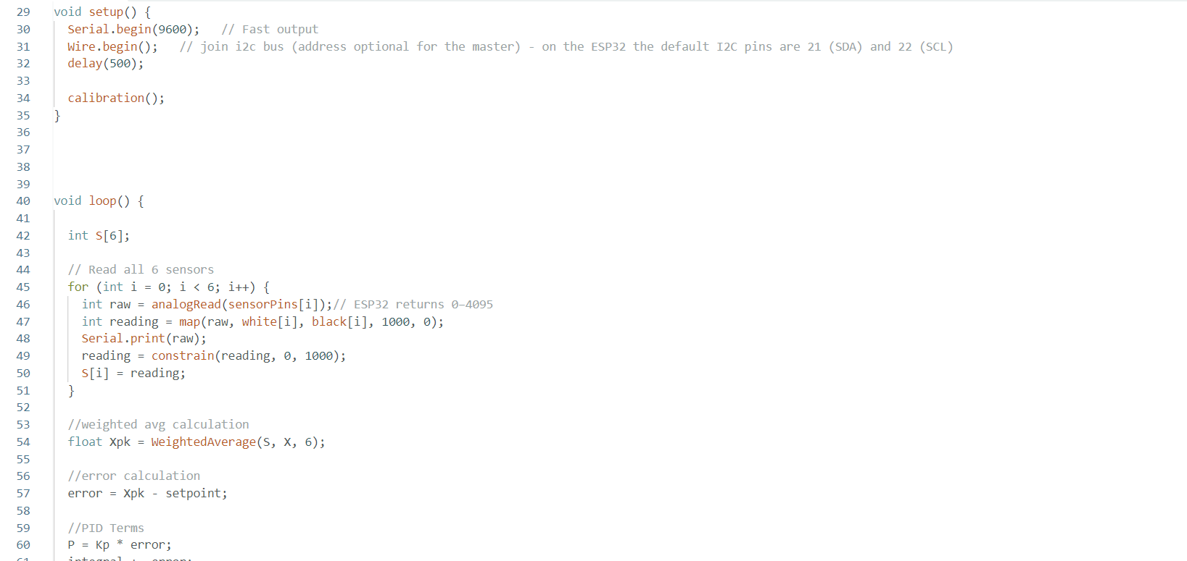
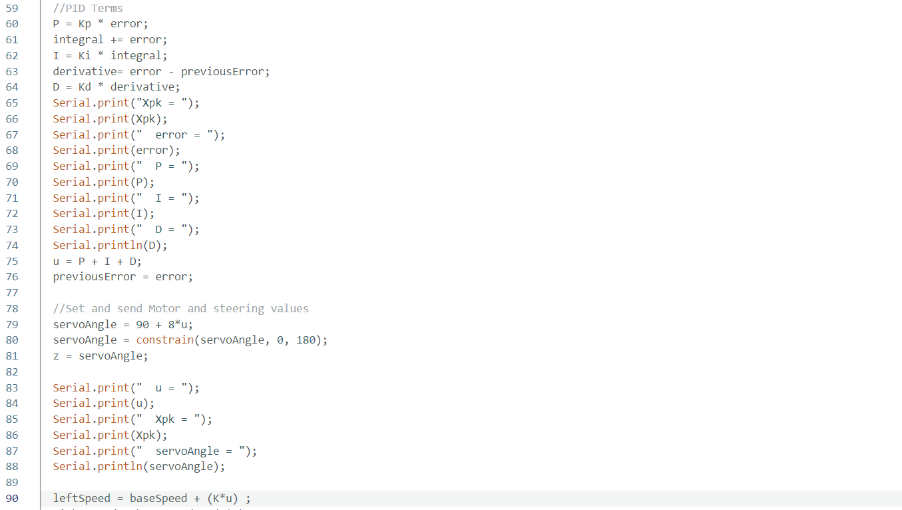
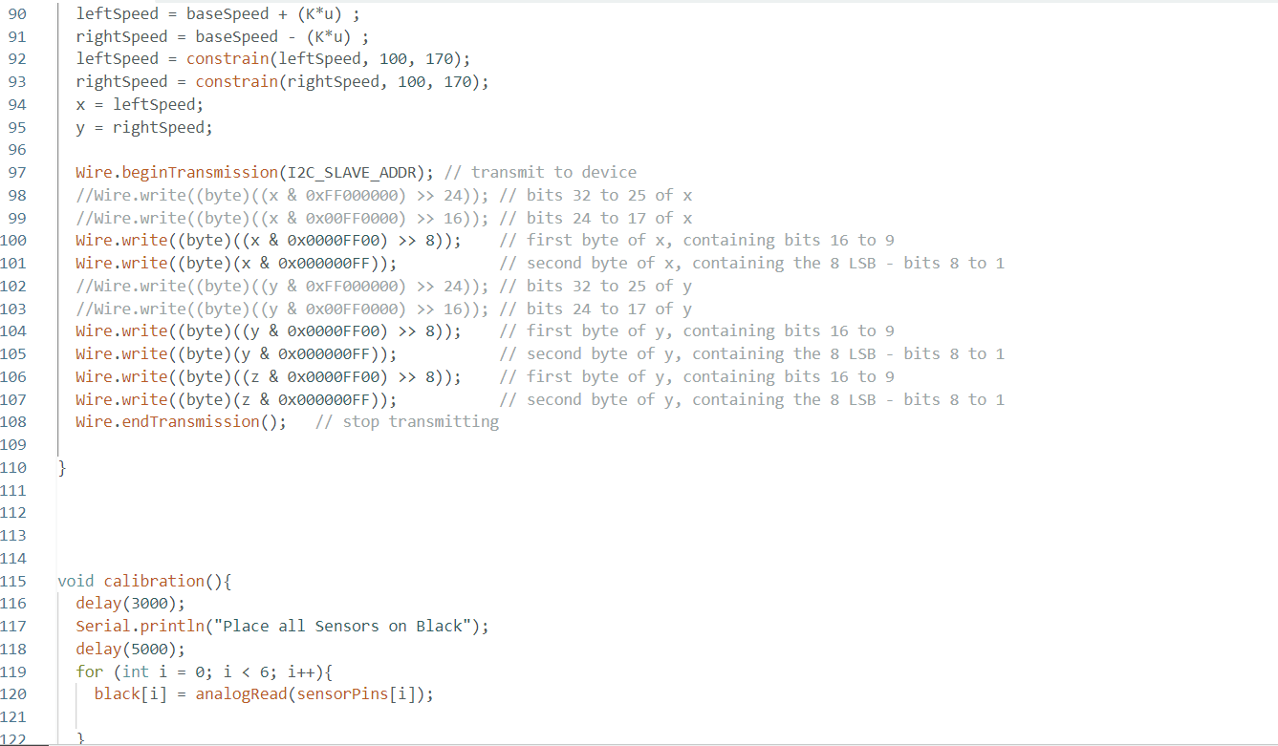
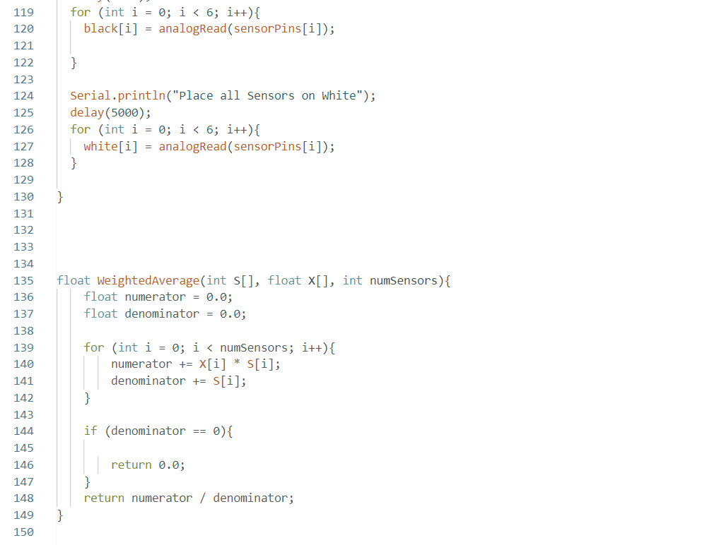
20/02/2026
I had to change my numbers a few times depending on how my robot behaved. Making my robot slow helped it so the sensors have time to sense. My final numbers allowed my robot to follow the line fine but it could not do sharp turns. It followed an infinity symbol just fine but when it came to the sign off I couldn’t get the calibration right which was annoying I got it eventually.

